In line with our Sunsmart policy and commitment to student safety, the PFA is running a sunscreen fundraiser. We have chosen to support the Cancer Council. Money raised will contribute to future maintenance of our fabulous new shade sails.

We are offering two convenient sunscreen sizes in the SPF 50+ Active range.

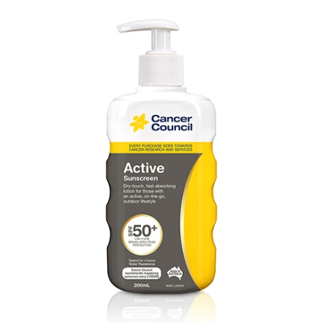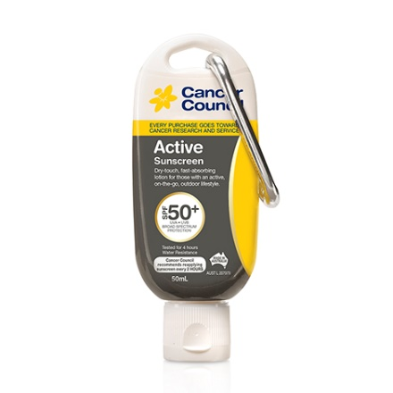

200mL pump bottle $17.50 50mL Ezi-Clip (refillable) $10

More details about these products can be found on: **www.cancercouncilshop.org.au/product/sunscreen-active-range.html**

Simply complete the order form below and return with payment**.**

Thank you

**PFA Team**

Friday, 1 February 2019

✂

**Sunscreen Order Form**

Student’s Name Class

I wish to order (Qty) Active Sunscreen Range SPF 50+ (200ml Pump) Amount $

(Qty) Active Sunscreen Range SPF 50+ (50ml Ezi-Clip) Amount $

Total Due $

Payment options: ◻ QKR (preferred) ◻ CASH ◻ EFT

Print Name of Parent/Guardian Signature of Parent/Guardian Date